

ITSIMPLERA SOLUTIONS
INTERNSHIP AI/ML
___________________________________________________________
WEEK 04
Submitted to | : | Itsimplera Solutions
Submitted by | : | Noor ul Fajar
Reg no | : | AIMLB01-0104

Week 4 Internship Report

Unsupervised Learning & Customer Segmentation

Task: Customer Segmentation using K-Means and Hierarchical Clustering
Dataset: Credit Card Dataset for Clustering (Kaggle) 8,950 customers, 17 behavioral features

1. Objective
This week's task moves from supervised to unsupervised learning. Instead of predicting a known target, the goal is to discover natural groupings within customer credit card behavior, balance, purchases, cash advance usage, and payment history, using clustering algorithms. These groupings can support real business decisions like targeted marketing, credit risk management, and personalized services.

2. Dataset Overview
- Rows: 8,950 credit card holders
- Features: 17 numeric behavioral features after dropping CUST_ID (identifier, not a feature)
- Time span: 6 months of behavioral data
- Missing values found:
  - CREDIT_LIMIT: 1 missing value
  - MINIMUM_PAYMENTS: 313 missing values
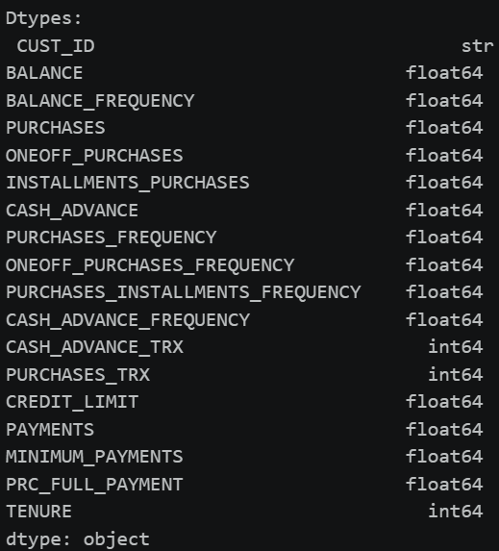
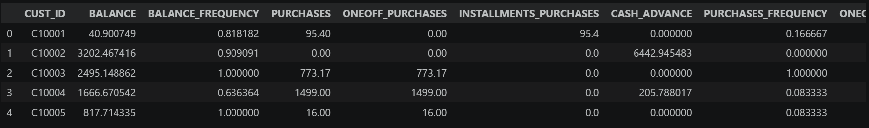

3. Data Preprocessing

3.1 Handling Missing Values
- CREDIT_LIMIT: the single missing row was dropped, losing 1 out of 8,950 customers has no meaningful effect on the analysis.
- MINIMUM_PAYMENTS: imputed using the median rather than the mean, since this is a skewed financial column and the median is more robust to outliers.
After these steps, 0 missing values remained across the dataset.
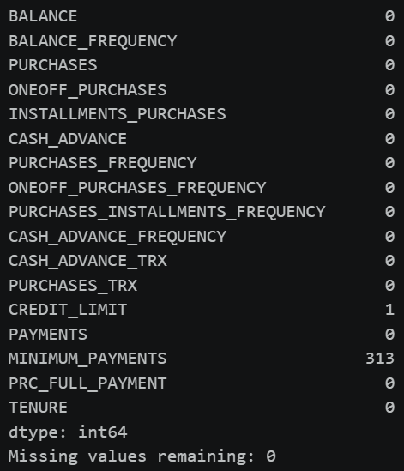

3.2 Feature Scaling
All 17 features were scaled using StandardScaler (mean 0, standard deviation 1) before clustering.
Scaling is mandatory for K-Means and hierarchical clustering because both rely on Euclidean distance to group similar points. Raw features in this dataset differ wildly in scale, BALANCE and PAYMENTS are in the thousands, while PURCHASES_FREQUENCY and BALANCE_FREQUENCY range between 0 and 1. Without scaling, the large-magnitude columns would dominate the distance calculation, and the frequency/ratio features, often just as informative for telling customers apart — would barely influence the clustering.
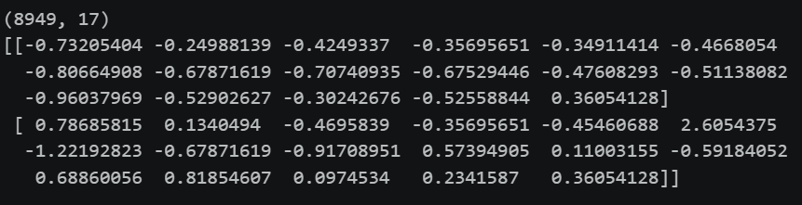

4. Part 1: K-Means Clustering

4.1 Choosing the Optimal k
K-Means was run for k = 2 through 10, recording inertia and silhouette score at each step.
Elbow method: Inertia decreases sharply through k=4, then flattens, the drop from k=3→4 (~12,908) is notably larger than the drop from k=4→5 (~7,267), marking the elbow.
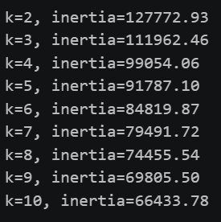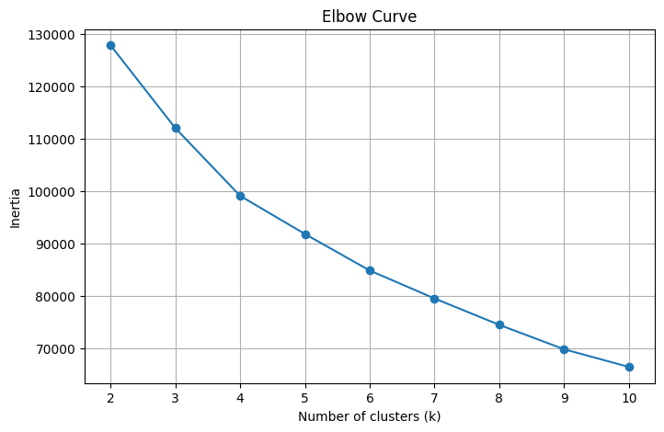
Silhouette method: Peaks sharply at k=3 (0.2506), dips at k=4–5, then rises gradually toward k=9 without beating k=3.
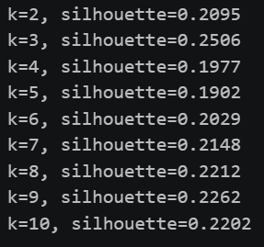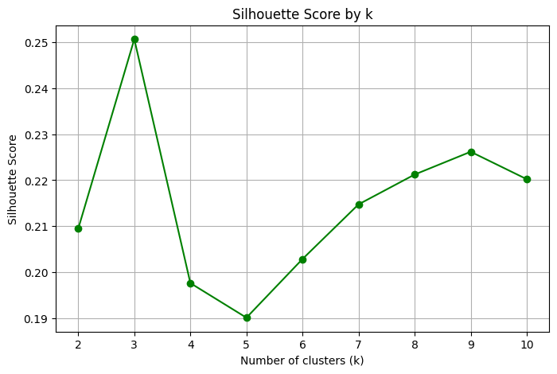
Conclusion: The two methods don't fully agree, silhouette technically favors k=3, while the elbow points to k=4. Overall silhouette scores are low across the board (all under 0.26), suggesting these customer segments aren't sharply separated, expected for real behavioral data, which tends to sit on a spectrum rather than form tight, distinct groups.
k=4 was selected as the final choice: it's supported by the elbow, its silhouette score (0.1977) is still reasonable relative to the range, and it produces enough distinct segments for meaningful business interpretation without over-fragmenting the customer base.

4.2 Final Clustering Results

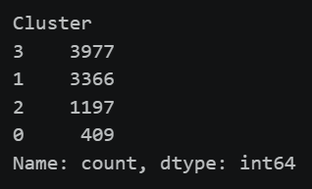

4.3 Cluster Profiling
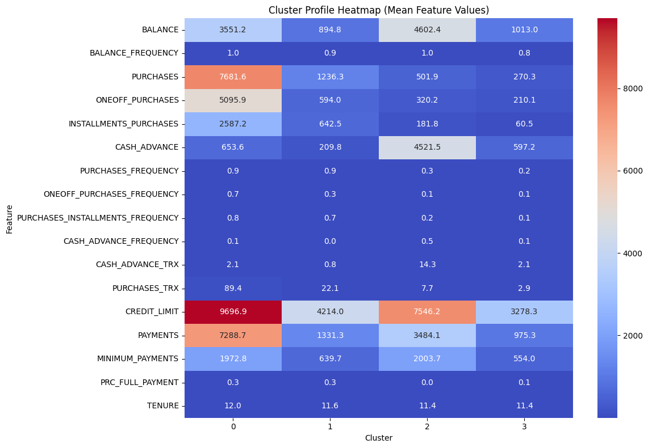
Cluster | Profile
0 | Premium spenders: highest purchases (7,681.6), one-off purchases, installment purchases, credit limit (9,696.9), and payments (7,288.7); purchases almost every month; most valuable segment
1 | Regular transactors:moderate spend, high purchase frequency (0.89), lowest cash advance frequency (0.04); largest "healthy" segment
2 | Cash advance users: low purchases (501.9) and purchase frequency (0.29), but highest cash advance amount (4,521.5) and frequency (0.5); highest-risk segment
3 | Low-activity customers: lowest activity across nearly every feature; largest group overall; candidates for re-engagement

5. Part 2: Hierarchical Clustering

5.1 Method
Agglomerative Hierarchical Clustering (Ward linkage) was applied to a random sample of 300 rows from the scaled dataset (full-dataset hierarchical clustering is computationally expensive at scale).
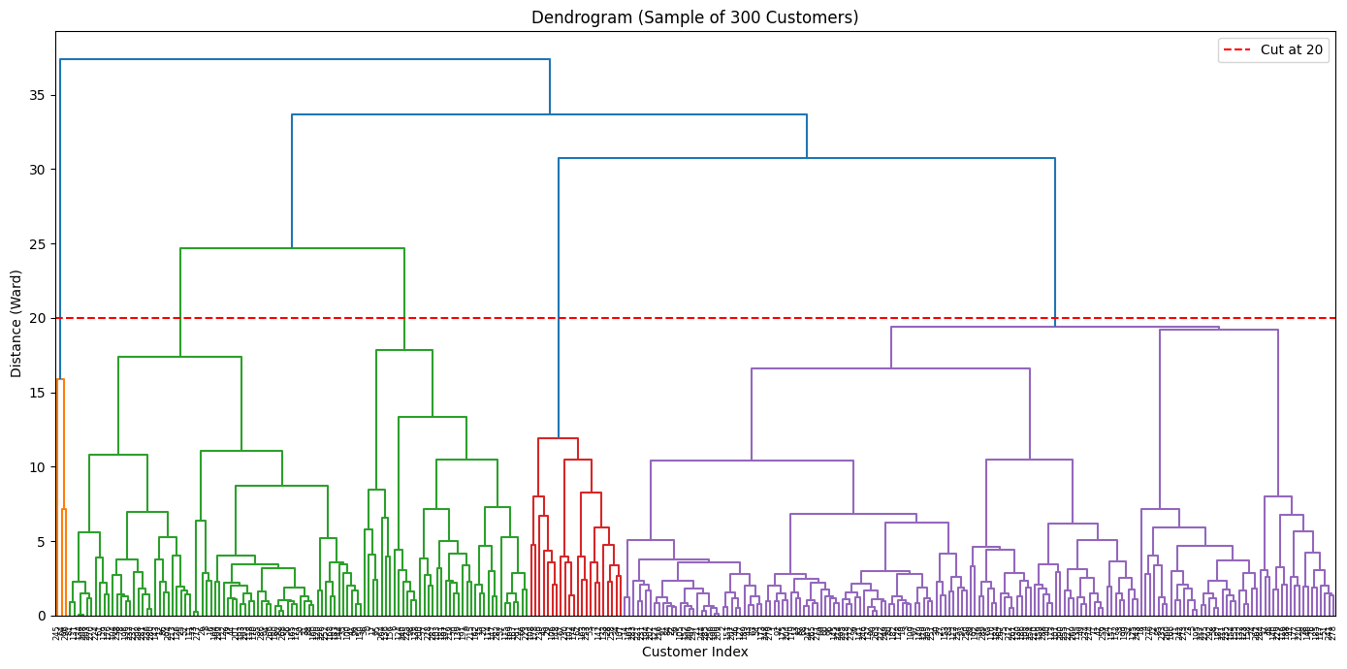
The dendrogram was cut at distance = 20, chosen by inspecting the tree and confirming this height splits it into exactly 4 branches, matching k=4 from Part 1.

5.2 Comparison with K-Means
AgglomerativeClustering (n_clusters=4) was applied to the same 300-row sample, and results were compared against the K-Means labels for those same customers using a crosstab.
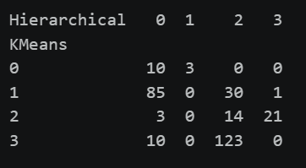
Agreement: Both methods clearly separate cash-advance-heavy customers and identify a large low-activity segment, the two most behaviorally distinct groups.
Disagreement: Hierarchical clustering blurs the line between "regular transactors" and "low-activity" customers, mixing them into overlapping branches where K-Means keeps them separate. Hierarchical clustering also split off a very small (3-customer) sub-cluster of premium spenders rather than keeping that segment intact as one group.

5.3 Recommendation
K-Means is the recommended method for real business use. It scales to the full ~9,000 customers (hierarchical clustering only ran on a 300-row sample due to computational cost), produces more consistent and evenly-sized segments, and is simpler to explain to non-technical stakeholders such as marketing or risk teams. Hierarchical clustering remains useful for exploratory analysis, the dendrogram visually shows how sub-groups nest and merge, but turning it into clean business segments requires more manual judgment.

Conclusion
Segmenting customers by behavior rather than demographics reveals four clear, actionable groups: a small premium segment worth retention efforts, a large stable base of regular users, a higher-risk cash-advance-dependent group, and a large inactive segment that represents a re-engagement opportunity. K-Means, at k=4, gives the clearest and most business-usable version of this segmentation, while hierarchical clustering served as a useful cross-check on structure.

